**NDSU Bison Strides**

**2024 REGISTRATION PACKET**

**NDSU Bison Strides** [ndsu.bisonstrides@ndsu.edu](mailto:ndsu.bisonstrides@ndsu.edu)

**Hultz Hall 100**

**Dept 7630, PO Box 6050**

**Fargo, ND 58108**

**701-231-9611**

Welcome! Please find policies and procedures, as well as registration forms and information in this packet. Questions can be directed to Erika Berg, Program Director, by e-mailing [ndsu.bisonstrides@ndsu.edu](mailto:ndsu.bisonstrides@ndsu.edu) or by calling 701-231-9611.

1. Participant Information
   1. For the safety of participants and in accordance with best industry practices, NDSU follows all Professional Association of Therapeutic Horsemanship International (PATH Intl.) Standards for Certification and Accreditation which includes contraindications for participation in equine assisted services. Examples include (but are not limited to) uncontrolled seizures and atlantoaxial instability.
   2. Participants must be able to sit up unassisted while riding a horse for 45 minutes with sufficient head control.
   3. The minimum age for participants in the Adapted Horsemanship program is 4 years old and the age range for the Equine Assisted Learning program is 7 to 17 years old.
   4. To protect our riders, horses, and volunteers we have established a weight limit of 170 pounds for mounted classes.
   5. Required attire for Adapted Horsemanship classes are long pants, shirts that cover participant’s torso, boots or close-toed and heeled shoes (tennis shoes are fine but NO sandals or Crocs) and an ASTM-SEI helmet approved for equestrian use (provided by Bison Strides).
   6. Attire for Equine Assisted Learning and Military and Veteran’s classes are long pants, shirts that cover participant’s torso, and cowboy/paddock boots (NO tennis shoes, sandals or Crocs; Bison Strides will provide boots if needed).
2. Registration
   1. Registration is on a first come, first served basis and after this a waitlist is implemented.
   2. All paperwork must be completed and returned to NDSU at the address above or scanned and e-mailed to [ndsu.bisonstrides@ndsu.edu](mailto:ndsu.bisonstrides@ndsu.edu) by deadlines on the following page.
   3. All new participants will be scheduled for a 30-min orientation at the Equine Center once paperwork has been received.
   4. **No one will be allowed to participate without completed paperwork and current physician’s release form**.
3. Payment
   1. Cost for the Adapted Horsemanship and Equine Assisted Learning classes is $300 for a 6-week session.
   2. Military and Veteran’s programming is subsidized through grants, the Wounded Warrior Project and donors so there is no cost to the service member.
   3. Half of the payment is due with registration and the remainder due prior to the first class.
   4. Payments may be made via check or on-line (please see Bison Strides website “Programs” tab for link to select amount of payment).
   5. Financial Assistance is available for qualified candidates. Application may be found on the Bison Strides website “Programs” tab or contact Erika Berg for information).
4. Attendance and Cancellation Policy
   1. Please give 24-hour notice when possible by calling 701-231-9611 and leaving a message or e-mailing [ndsu.bisonstrides@ndsu.edu](mailto:ndsu.bisonstrides@ndsu.edu).
   2. No refunds will be issued for missed classes and only one make-up is allowed per session.
   3. If Bison Strides must cancel, classes will be rescheduled.
5. Facility Safety
   1. Participants must enter on the south side of the east entrance (please see map on the last page) and stay within the designated areas of the Bison Strides alley, bleachers or bathrooms at all times.
   2. Parents/guardians/caregivers must remain at the Equine Center during lessons and children may not be left unattended.
   3. For participant safety, anyone disrupting classes will be asked to leave the immediate area
   4. No mistreatment, abuse or suggested abuse of any person or animal will be tolerated.
   5. We reserve the right to ask anyone to leave the premises.
6. Drugs, Alcohol, Firearms: NDSU is a non-smoking, tobacco-free facility and the use of drugs or alcohol on the property is strictly forbidden as is attending sessions under the influence of drugs or alcohol and will result in immediate dismissal from the program. No firearms, ammunition or weapons are permitted.

**Bison Strides 2024 Programming Dates (*subject to change)**

|  |  |  |  |
| --- | --- | --- | --- |
| **Session** | **Dates** | **Registration Open &**  **Financial Assistance Due** | **Registration Due** |
| Winter | Jan 30 to Mar 8 (March 12 to 15 make-ups)  Tuesday 5-6 p.m. Adapted horsemanship  Tuesday 6-7 p.m. Equine assisted learning  Thursday 9-11 a.m. Adapted horsemanship  Fri 8:30-9:30 a.m. Military and Veterans | Jan 1 | Jan 15 |
|  |  |  |  |
| Spring | Apr 2 to May May 10 (May 14 to May 16 make-ups)  Tuesday 5-6 p.m. Adapted horsemanship  Tuesday 6-7 p.m. Equine assisted learning  Thursday 9-11 a.m. Adapted horsemanship  Thursday 4-6 p.m. Adapted horsemanship  Friday 8:30-9:30 a.m. Military and Veterans | Mar 1 | Mar 15 |
|  |  |  |  |
| Summer 1 | May 14 to June 23 (June 25 to Jun 30 make-ups)  Mon 4-7 p.m. Adapted horsemanship  Tues 4-7 pm. Adapted horsemanship  Thurs 4-5 p.m. Adapted horsemanship  Thurs 5-7 p.m. Equine Assisted Learning  Fri 8:30-9:30 a.m. Military and Veteran | Apr 15 | May 1 |
| Summer 2 | July 14 to August 18  Fri 8:30-9:30 a.m. Military and Veteran |  |  |
| Fall 1 | Sept 10 to Oct 20 (Dec 3 to Dec 8 make-ups)  Mon 6-7 p.m. Adapted horsemanship  Mon 7-8 p.m. Equine Assisted Learning  Tues 9-11 a.m. Adapted horsemanship  Tues 5:30-6:30 p.m. Adapted horsemanship  Fri 8:30-9:30 a.m. Military and Veteran | Aug 15 | Aug 30 |
| Fall 2 | Oct 22 to Dec 1 (Dec 3 to Dec 8 make-ups)  Mon 6-7 p.m. Adapted horsemanship  Mon 7-8 p.m. Equine Assisted Learning  Tues 9-11 a.m. Adapted horsemanship  Tues 5:30-6:30 p.m. Adapted horsemanship  Fri 8:30-9:30 a.m. Military and Veteran | Oct 1 | Oct 15 |

**NDSU Bison Strides** [ndsu.bisonstrides@ndsu.edu](mailto:ndsu.bisonstrides@ndsu.edu)

**Hultz Hall 100**

**Dept 7630, PO Box 6050**

**Fargo, ND 58108**

**701-231-9611**

**NDSU Bison Strides 2024 Registration (Please type or print)**

**____ I have read and agree to the policies on the first two pages**

Participant name: _________________________________________________ Date of birth:_____________

Street: ________________________________________ City: _______________ State: ____ Zip: _________

Primary Phone: ___________________________ Other phone:_______________________________

E-mail: ___________________________________________ Preferred Contact Method: _phone _email _mail

If under age 18 or dependent adult, please list parent/guardian/caregiver name(s) and contact number(s):

Name: ______________________________ Phone: __________________ Relationship: ________________

Name: ______________________________ Phone: __________________ Relationship: ________________

In case of emergency, please contact the following if other than parent/guardian/caregiver:

Name: ______________________________ Phone: __________________ Relationship: ________________

Name: ______________________________ Phone: __________________ Relationship: ________________

**Winter 2024 Classes Apr 2 to May 10**

* Please direct any questions on program type or class placement to Erika Berg.
* Please note that we will work to place participants in the class most suitable for their horsemanship skill level and age.
* If applicable, please indicate your 1st, 2nd and 3rd session/day/time choices below.

|  |  |  |  |
| --- | --- | --- | --- |
| **Equine Assisted Learning**  **(ground-based program, no riding) for youth age 7-17 years addressing social, emotional, or behavioral concerns)**  ___ Tues 6-7 pm  **Adapted Horsemanship**  **(minimum of 4 years old, development of riding skills)**  ___ Tues 5-6 pm  ___ Thurs 9-10 am  ___ Thurs 10-11 am  ___ Thurs 4-5 pm  ___ Thurs 5-6 pm | **Military and Veterans Horsemanship Program (ground-based, no riding)**  ___ Friday 8:30-9:30 am | | |
| **Service Status**  ___ Veteran  ___ Active duty  ___ Active reserve  ___ Inactive reserve  ___ Retired  ___ Other:_______ | **Service Branch**  ___ Air Force  ___ Air National  Guard  ___ Army  ___ Army National  Guard  ___ Coast Guard  ___ Marine  ___ Navy  ___ Other:________ | **Service Era**  ___ Post 9/11  ___ Cold War  ___ Desert Storm  ___ Vietnam  ___ Korea  ___ World War II |

**NDSU Bison Strides** [ndsu.bisonstrides@ndsu.edu](mailto:ndsu.bisonstrides@ndsu.edu)

**Hultz Hall 100**

**Dept 7630, PO Box 6050**

**Fargo, ND 58108-6050**

**701-231-9611**

Previous riding or horsemanship-related experience:

___None ___Minimal ___Moderate ___Extensive

Support while riding:

___Spotter or Horse Handler ___Sidewalkers ___Independent

If previous horsemanship experience, please tell us the year started, the frequency and any other information that may be helpful.

___________________________________________________________________________________

___________________________________________________________________________________

___________________________________________________________________________________

___________________________________________________________________________________

Below please describe your horsemanship goals as well as goals for improved daily living skills:

1. ___________________________________________________________________________________

2. ___________________________________________________________________________________

3. ___________________________________________________________________________________

4. ___________________________________________________________________________________

5. ___________________________________________________________________________________

**PHOTO RELEASE:**

___ I DO consent to and authorize the use and reproduction by NDSU of any and all photographs and any other audio/visual materials taken of me or my minor child or dependent for promotional material, educational activities, exhibitions (including website or social media) for any other use for the benefit of the NDSU Bison Strides.

___ I DO NOT consent to and authorize the use and reproduction by NDSU of any and all photographs and any other audio/visual materials taken of me or my minor child or dependent for promotional material, educational activities, exhibitions (including website or social media) or for any other use for the benefit of the NDSU Bison Strides.

**PHOTO POLICY:** Photostaken at NDSU of riders/volunteers other than YOUR child may NOT be posted to Facebook or other social media sites. Please respect the privacy of all participants & volunteers.

___ Please check to confirm you have signed the Participation, Waiver and Release of Liability Form or Minor Participation, Waiver and Release of Liability Form contained in this packet

**NDSU Bison Strides** [ndsu.bisonstrides@ndsu.edu](mailto:ndsu.bisonstrides@ndsu.edu)

**Hultz Hall 100**

**Dept 7630, PO Box 6050**

**Fargo, ND 58108-6050**

**701-231-9611 Physician Information**

**(page 1 of 4 for physician)**

Date: ________________

Dear Health Care Provider:

Your patient, ______________________________ is interested in participating in supervised equine assisted

(*participant’s name*)

services. In order to safely provide this program, our center requests that you complete/update the attached Medical History and Physician’s Release Form. Please note that the following conditions may suggest precautions and contraindications to equine activities. Therefore, when completing this form, please note whether these conditions are present, and to what degree.

|  |  |
| --- | --- |
| **Orthopedic**  Atlantoaxial Instability - include neurologic symptoms  Coxarthrosis  Cranial defects  Heterotopic ossification/myositis ossificans  Joint subluxation/dislocation  Osteoporosis  Pathologic fractures  Spinal joint fusion/fixation  Spinal joint instability/abnormalities  **Neurologic**  Hydrocephalus/shunt  Seizures  Spina bifida/Chiari II malformation/tethered cord /  /hydromyelia  **Other**  Age - under 5 years  Indwelling catheters/medical equipment  Medications - e.g., photosensitivity  Poor endurance  Skin breakdown | **Medical/Psychological**  Allergies  Animal abuse  Cardiac condition  Physical/sexual/emotional abuse  Blood pressure control  Dangerous to self or others  Exacerbations of medical conditions (e.g., RA, MS) Fire setting  Hemophilia  Medical instability  Migraines  Peripheral vascular disease  Respiratory compromise  Recent surgeries  Substance abuse  Thought control disorders  Weight control disorders |

Thank you very much for your assistance. If you have any questions or concerns regarding this patient’s participation in equine-assisted services, please feel free to contact me at the address/phone/e-mail below. Paperwork can also be mailed to the below address.

Sincerely,

Erika Berg, NDSU Bison Strides Program Director

[erika.berg@ndsu.edu](mailto:erika.berg@ndsu.edu)

Hultz Hall 100

Dept 7630, PO Box 6050

Fargo, ND 58108-6050

701-231-9611

**2024 Participant Medical History**

**For review by participant’s physician (page 2 of 4 for physician)**

This form must be updated annually and submitted with required signatures

Participant: ________________________________________________________ DOB: ________________

Primary Diagnosis: _________________________________________________ Onset: ________________

Secondary Diagnosis _______________________________________________ Onset: ________________

Other Diagnoses: _______________________________________________ Onset: ________________

|  |  |  |  |  |
| --- | --- | --- | --- | --- |
| Participant is:  (check all that apply) | __ Verbal  __ Verbal assisted  __ Non-verbal | __ Hearing  __ Hearing assisted  __ Deaf | __Ambulatory  __Ambulatory assisted  __ Non-ambulatory | __ Seeing  __ Seeing with assist  __ Blind |

Please list all current medications

1. __________________________________________ Taken for: _________________________
2. __________________________________________ Taken for: _________________________
3. __________________________________________ Taken for: _________________________
4. __________________________________________ Taken for: _________________________

Current/previous therapies:

___ OT: ______________________________________________________________________

___ PT: _______________________________________________________________________

___ Speech: ___________________________________________________________________

___ Other: _____________________________________________________________________

_________________________________________________________________ _________

**Required participant signature or parent/guardian of dependent participant Date**

**2024 Participant’s Medical History**

**For completion by participant’s physician (page 3 of 4 for physician)**

Participant’s Name: ________________________________ Date: __________

|  |  |  |  |
| --- | --- | --- | --- |
| **Concern** | **Yes** | **No** | **History/Describe** |
| Allergies |  |  |  |
| Asthma/COPD |  |  |  |
| Auditory |  |  |  |
| Balance |  |  |  |
| Cardiac |  |  |  |
| Circulatory |  |  |  |
| Cognitive |  |  |  |
| Communication |  |  |  |
| Emotional |  |  |  |
| Integumentary |  |  |  |
| Immune function |  |  |  |
| Joints – dislocating or subluxing |  |  |  |
| Laminectomy/Fusion |  |  |  |
| Learning disability |  |  |  |
| Muscular |  |  |  |
| Neurologic |  |  |  |
| Orthopedic |  |  |  |
| Ossification |  |  |  |
| Osteoporosis |  |  |  |
| Pain |  |  |  |
| Pulmonary |  |  |  |
| Psychological |  |  |  |
| Respiratory |  |  |  |
| Scoliosis |  |  | Degree: ___________ Type: _____________________ |
| Seizure type:____________ |  |  | Controlled: __ Yes __ No Last seizure date: ________ |
| Shunt |  |  |  |
| Speech |  |  |  |
| Spinal column injury |  |  |  |
| Spondylolisthesis |  |  |  |
| Surgical implants |  |  |  |
| Surgeries |  |  |  |
| Tactile |  |  |  |
| Vision |  |  |  |
| Other |  |  |  |
| **Mobility:** Independent ambulation? |  |  |  |
| Cane/crutches/walker |  |  |  |
| Orthotics |  |  |  |
| Prosthetics |  |  |  |
| Wheelchair |  |  |  |

**2024 Participant’s Physician’s Release Form**

**For completion by participant’s physician (page 4 of 4 for physician)**

Participant’s Name: __________________________________ DOB: __________

Primary diagnosis: ___________________________________________________________

**Height ___________ Weight ____________**

**We must have both height and weight information to determine participant suitability for mounted equine activities and therapies, as well as to appropriately match horses and riders.**

Please list any specific limitations not noted elsewhere on medical history:

All participants with Down syndrome must have an ANNUAL certification from their physician that a neurologic and/or physical examination reveals no sign of atlantoaxial instability or decrease in neurologic function.

1. ANNUAL neurologic/physical exam for AAI/decreased neurologic function:
   1. ___ Positive ___ Negative Exam date: _____________
2. Most recent cervical x-ray for AAI
   1. ___ Positive ___ Negative X-ray date _____________

I have reviewed the medical history on this page and previous pages and release my patient to participate in equine assisted services (EAS) at NDSU Bison Strides. I am aware and permit my patient to actively participate in the areas of EAS including sitting astride a horse, riding a horse, grooming a horse and other equine related ground activities. Given the above diagnosis and medical information on the previous pages, this person is not medically precluded from participation in EAS at NDSU Bison Strides. **I understand that NDSU Bison Strides will weigh the medical information given against the existing industry precautions and contraindications described by the Professional Association of Therapeutic Horsemanship International (PATH Intl**). Therefore, I refer this person to the NDSU Bison Strides for ongoing evaluation to determine eligibility for participation.

Physician’s name: ____________________________________ __ MD __ DO __ NP __ PA Other:_______

**Physician’s signature**:___________________________________________________ **Date**:___________

License/UPIN # ____________________________________

Office address: _________________________________ City: ____________ State: _____ Zip ____________

Office phone:____________________________________ Office fax: _________________________________

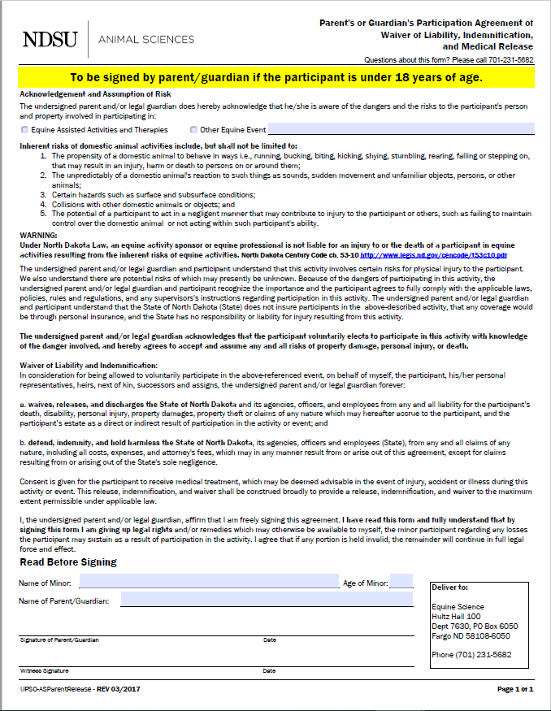

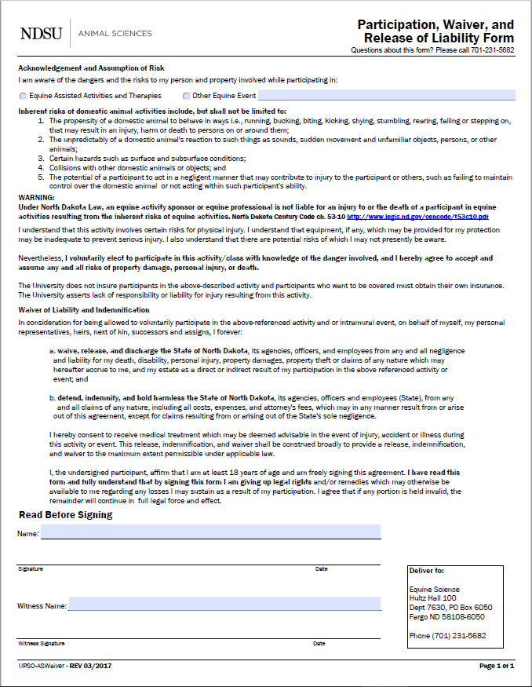

**Directions to NDSU Equine Center**

NDSU Equine Center

5140 19th Ave North, Fargo

From I-29 take the 19th Ave N exit (#67) and drive west 2 miles to the Equine Center OR you can drive north on Veterans Blvd (this will change into 9th St E) and then turn right (east) onto 19th Ave N. The NDSU Equine Center will be on the south side of the road. There is a brick “NDSU Equine Center” sign and the long metal building is tan with a red roof. Once you enter the main driveway you will drive around the east end of the building and turn right to drive along the length of the south side to park and enter the door with the sign below (please see map below for clarification).

You will see the sign below on the door.



