NDSU Bison Strides
2026 REGISTRATION PACKET

NDSU Bison Strides ndsu.bisonstrides@ndsu.edu
Hultz Hall 100
Dept 7630, PO Box 6050
Fargo, ND 58108
701-231-9611

Welcome! Please find policies and procedures, as well as registration forms and information in this packet. Questions can be directed to Erika Berg, Program Director, by e-mailing ndsu.bisonstrides@ndsu.edu or by calling 701-231-9611.
- Participant Information
  - For the safety of participants and in accordance with best industry practices, NDSU follows all Professional Association of Therapeutic Horsemanship International (PATH Intl.) Standards for Certification and Accreditation which includes contraindications for participation in equine assisted services. Examples include (but are not limited to) uncontrolled seizures and atlantoaxial instability.
  - Participants must be able to sit up unassisted while riding a horse for 45 minutes with sufficient head control.
  - The minimum age for participants in the Adapted Horsemanship program is 4 years old and the age range for the Equine Assisted Learning program is 6 to 17 years old.
  - To protect our riders, horses, and volunteers we have established a weight limit of 170 pounds for mounted classes.
  - Required attire for Adapted Horsemanship classes are long pants, shirts that cover participant’s torso, boots or close-toed and heeled shoes (tennis shoes are fine but NO sandals or Crocs) and an ASTM-SEI helmet approved for equestrian use (provided by Bison Strides).
  - Attire for Equine Assisted Learning and Military and Veteran’s classes are long pants, shirts that cover participant’s torso, and cowboy/paddock boots (NO tennis shoes, sandals or Crocs; Bison Strides will provide boots if needed).
- Confidentiality: NDSU Bison Strides abides by all state and federal laws regarding the protection of personally identifiable information.
- Registration
  - Registration is on a first come, first served basis and after this a waitlist is implemented.
  - All paperwork must be completed and returned to NDSU at the address at the top left corner of this page or scanned and e-mailed to ndsu.bisonstrides@ndsu.edu.
  - All new participants will be scheduled for a 30-min orientation at the Equine Center once paperwork has been received.
  - Once we have received your registration, you will be sent a Medical Authorization Form. No one will be allowed to participate without completed registration paperwork, current (within 1 year) Medical Authorization Form, and liability waiver submitted.
- Payment
  - Cost for the Adapted Horsemanship and Equine Assisted Learning classes is $300 for a 6-week session and $200 for a 4-week session.
  - Financial Assistance is available for qualified candidates. Application may be found on the Bison Strides website “Programs” tab or contact ndsu.bisonstrides@ndsu.edu for information). Please check the following: I ___ DO or I ___ do NOT plan to apply for Financial Assistance.
  - Military and Veteran’s programming is subsidized through grants and donors so there is no cost for the service member to participate in up to 2 hours of programming per week.
  - Once registration is confirmed, payment is due upon receipt of invoice link that will be sent via e-mail. Payments via check may also be made if needed with questions directed to ndsu.bisonstrides@ndsu.edu.

- Attendance and Cancellation Policy – PLEASE NOTE CHANGES IN BOLD BELOW
  - Please give 48-hour notice when possible by calling 701-231-9611 and leaving a message or e-mailing ndsu.bisonstrides@ndsu.edu.
  - No refunds will be issued for missed classes and only one make-up is offered per NDSU academic semester.
  - If Bison Strides must cancel for any reason, classes will be rescheduled.
- Facility Safety
  - Participants must enter on the south side of the east entrance (please see map on the last page) and stay within the designated areas of the Bison Strides alley, bleachers or bathrooms at all times.
  - Parents/guardians/caregivers must remain at the Equine Center during lessons and children may not be left unattended.
  - For participant safety, anyone disrupting classes will be asked to leave the immediate area.
  - No mistreatment, abuse or suggested abuse of any person or animal will be tolerated.
  - We reserve the right to ask anyone to leave the premises.
- Drugs, Alcohol, Firearms: NDSU is a non-smoking, tobacco-free facility and the use of drugs or alcohol on the property is strictly forbidden, as is attending sessions under the influence of drugs or alcohol and will result in immediate dismissal from the program. No firearms, ammunition or weapons are permitted.

NDSU Bison Strides ndsu.bisonstrides@ndsu.edu
Hultz Hall 100
Dept 7630, PO Box 6050
Fargo, ND 58108
701-231-9611
NDSU Bison Strides 2026 Registration (Please type or print)
____ I have read and agree to the policies on the first two pages
Participant name: _________________________________________________ Date of birth:_____________
Street: ________________________________________ City: _______________ State: ____ Zip: _________
Primary Phone: ___________________________ Other phone:_______________________________
E-mail: ___________________________________________ Preferred Contact Method: _phone _email _mail

If under age 18 or dependent adult, please list parent/guardian/caregiver name(s) and contact number(s):
Name: ______________________________ Phone: __________________ Relationship: ________________
E-mail: ______________________________________________________

In case of emergency, please contact the following if other than parent/guardian/caregiver:
Name: ______________________________ Phone: __________________ Relationship: ________________
E-mail: ______________________________________________________

- Please direct any questions on program type or class placement to Erika Berg ndsu.bisonstrides@ndsu.edu
- Please note that we will work to place participants in the class most suitable for their horsemanship skill level and age.
- Fall 1: September 14th – October 23rd

Equine Assisted Learning  (ground-based program for youth age 6-17 years with social, emotional, or behavioral concerns)  ___ Tuesday 5:30-6:30 pm  Adapted Horsemanship  (minimum of 4 years old, development of riding skills)  ___ Monday 6-7pm  ___ Tuesday 9-10 am  ___ Tuesday 10-11 am  ___ Tues 4:30- 5:30pm | Military and Veterans Horsemanship Program (can select both)  ___ Monday 7-8pm ___ Friday 8:30-9:30 am
 | Service Status  ___ Veteran  ___ Active duty  ___ Active reserve  ___ Inactive reserve  ___ Retired  ___ Other:_______ | Service Branch  ___ Air Force  ___ Air National  Guard  ___ Army  ___ Army National  Guard  ___ Coast Guard  ___ Marine  ___ Navy | Service Era  ___ Post 9/11  ___ Cold War  ___ Desert Storm  ___ Vietnam  ___ Korea  ___ World War II
NDSU Bison Strides ndsu.bisonstrides@ndsu.edu
Hultz Hall 100
Dept 7630, PO Box 6050
Fargo, ND 58108-6050
701-231-9611

Previous riding or horsemanship-related experience:
___ None ___ Minimal ___ Moderate ___ Extensive
Support while riding:
___ Spotter or Horse Handler ___ Sidewalkers ___ Independent
If previous horsemanship experience, please tell us the year started, the frequency and any other information that may be helpful.
___________________________________________________________________________________
___________________________________________________________________________________
___________________________________________________________________________________
___________________________________________________________________________________
Below please describe your horsemanship goals as well as goals for improved daily living skills:
1. ___________________________________________________________________________________
2. ___________________________________________________________________________________
3. ___________________________________________________________________________________
4. ___________________________________________________________________________________
5. ___________________________________________________________________________________

PHOTO RELEASE:
___ I DO consent to and authorize the use and reproduction by NDSU of any and all photographs and any other audio/visual materials taken of me or my minor child or dependent for promotional material, educational activities, exhibitions (including website or social media) for any other use for the benefit of the NDSU Bison Strides.

___ I DO NOT consent to and authorize the use and reproduction by NDSU of any and all photographs and any other audio/visual materials taken of me or my minor child or dependent for promotional material, educational activities, exhibitions (including website or social media) or for any other use for the benefit of the NDSU Bison Strides.

PHOTO POLICY: Photos taken at NDSU of riders/volunteers other than YOUR child may NOT be posted to Facebook or other social media sites. Please respect the privacy of all participants & volunteers.

___ Please initial to confirm you have signed and returned the Participation, Waiver and Release of Liability Form or Minor Participation, Waiver and Release of Liability Form and submitted

___ Please initial to confirm you have submitted the Medical Authorization Form if over one year since last completed or you are a new participant. THIS FORM MUST BE CURRENT AND SUBMITTED TO BISON STRIDES IN ORDER FOR PARTICIPANT TO RIDE
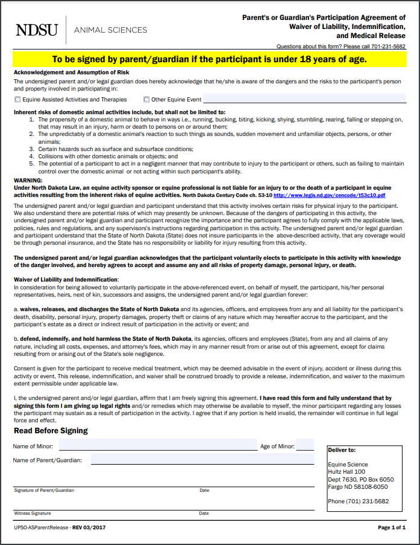
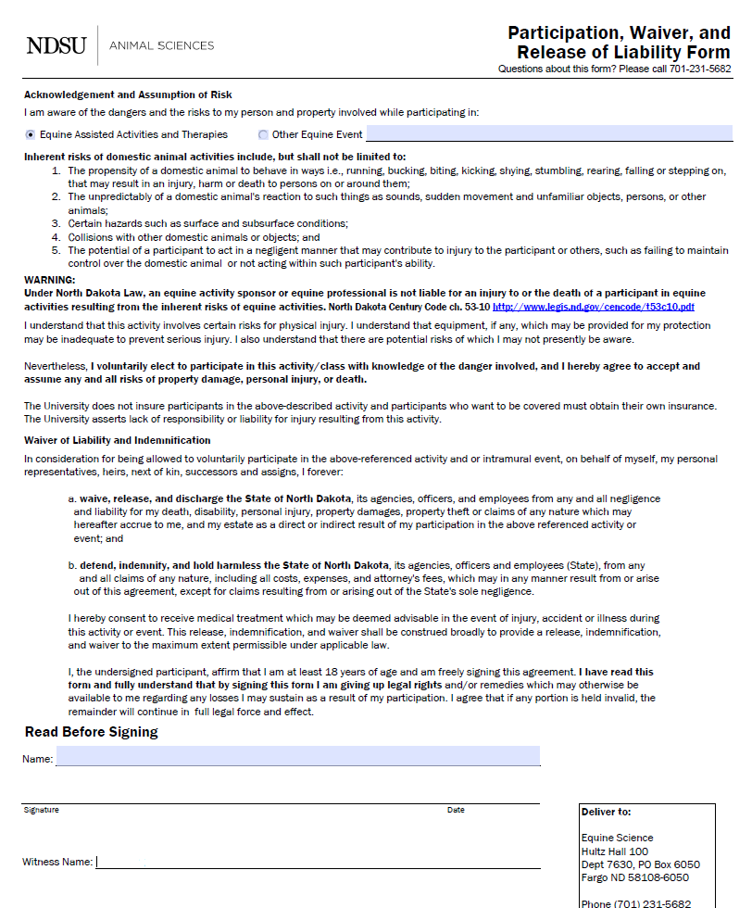

Directions to NDSU Equine Center

NDSU Equine Center
5140 19th Ave North, Fargo

From I-29 take the 19th Ave N exit (#67) and drive west 2 miles to the Equine Center OR you can drive north on Veterans Blvd (this will change into 9th St E) and then turn right (east) onto 19th Ave N. The NDSU Equine Center will be on the south side of the road. There is a brick “NDSU Equine Center” sign and the long metal building is tan with a red roof. Once you enter the main driveway you will drive around the east end of the building and turn right to drive along the length of the south side to park and enter the door with the sign below (please see map below for clarification).

You will see the sign below on the door.

